 | 
Project Executable Files
Date | 15 March 2026 5 July 2026
Team ID | xxxxxx 6a3a555ae5895b2c9759029d
Project Name | xxxxxx EduGenie - Google Gemini Powered Learning Assistant
Maximum Marks | 3 Marks
Project Executable Files
This section requires submission of all executable and deployable files for your project. Ensure all files are properly organized, named, and uploaded to the specified submission platform. The evaluator must be able to run or deploy your solution using the provided files and instructions.
Step 1: Submission Checklist
https://edugenie-google-gemini-powered-learning-n2zf.onrender.com/
S.No | Item to Submit  Not applicable - no authentication is currently implemented (single seeded default user). | Submitted​ (Yes​/  t user). No / NA)
1 | Complete source code (all files and folders) Docker container hosting, Render Web Services.
2 | README / Setup Guide (instructions to run the project)
3 | requirements.txt / package.json / dependency file
4 | Database schema / seed files (if applicable)
5 | Environment​ configuration​ file​ (.env.example​or  similar)
6 | Deployed application URL (if hosted)
7 | APK​ /​ Executable​ binary​ (if​ applicable​  for mobile/desktop apps)
8 | Dockerfile / Containerization config (if applicable)
9 | Test files and test results
10 | Demo video or walkthrough (if required)

 | 
https://edugenie-google-gemini-powered-learning-n2zf.onrender.com/
Not applicable - no authentication is currently implemented (single seeded default user).
Docker container hosting, Render Web Services.

 | 
Step 2: File / Folder Structure
Provide an overview of your project's file and folder structure below:
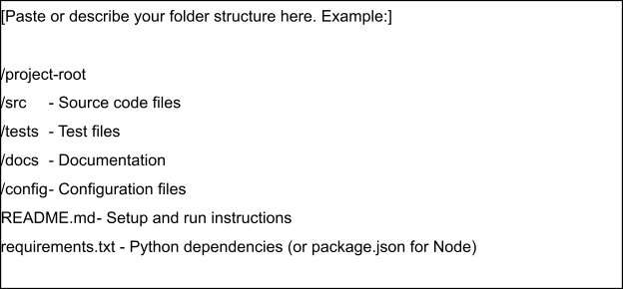
https://edugenie-google-gemini-powered-learning-n2zf.onrender.com/
Step 3: Deployment / Access Details
Not applicable - no authentication is currently implemented (single seeded default user).
Field | Details
Hosted / Deployed URL Docker containe | r hosting, Render Web Services.
Login​ Credentials  (Demo) | [Provide demo username and password for evaluator access]
Platform​ /​ Hosting  Provider | [e.g., Render, Vercel, AWS, Heroku, Azure]
Repository Link
Demo Video Link

 | 
Step 4: Run Instructions
Provide clear, step-by-step instructions for the evaluator to run your project locally:
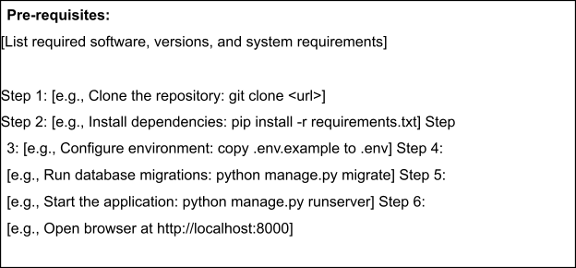
https://edugenie-google-gemini-powered-learning-n2zf.onrender.com/
Step 5: Known Issues / Limitations
Not applicable - no authentication is currently implemented (single seeded default user).
S.No | Known Issue / Limitation | Workaround / Status
1 | Docker container hosting, Render Web Services.
2
3

